EE222 Console Pic also question one answered below – Mario DeCristofaro – Oct 1, 2019

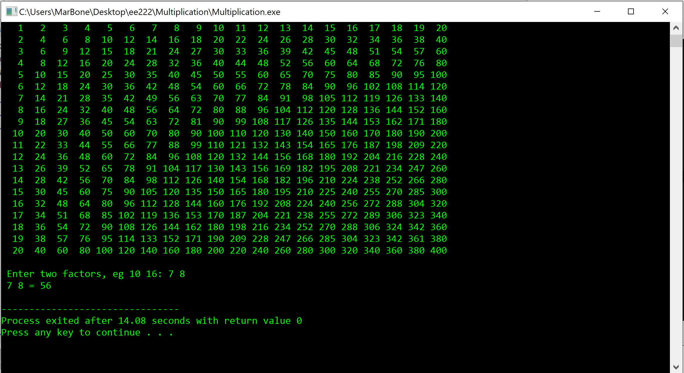

1. The main is running each individual method, then in the do while loop its, seeing if it’s the first time your inputting code, then if so it uses scan f to place x and y together. Then if x and y are greater than the dimension, then the print statement uses the tt_c_result with x and y to calculate the math for the result.